A New Image Coding Technique Unifying Fractal and Transform Coding
Kai Uwe Barthel, Jörg Schüttemeyer, Thomas Voyé and Peter Noll
IEEE International Conference on Image Processing, 13-16, pp. 112-116, Nov. 1994
Abstract
This paper presents a new image coding scheme based on an unification of fractal and transform coding.
- Introduction
A generalization of the luminance transform in the frequency domain. Fractal and transform coding are subsets of this transformation.
- The Principle of a Fractal Block-Coder
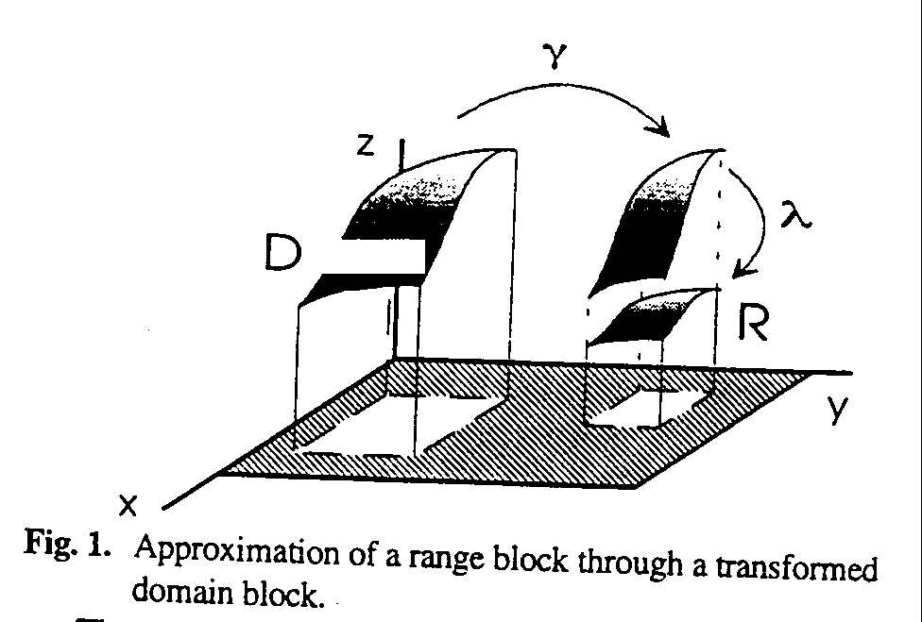
- The Principle of Fractal Based Transform Coding
  - Conventional Transform and Fractal Coders
The domain blocks that have been scaled down to the size the range blocks are referred to as codebook blocks.

  - A Luminance Transformation in the Frequency Domain
All range and codebook blocks (of size N·N) are transformed via the discrete cosine transform (DCT).
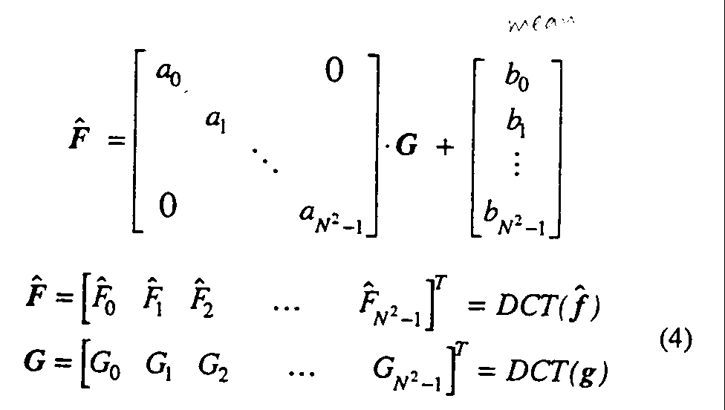

  - Fractal Based on Transform Coding(FTC)
Transform coding reduces intra-block redundancy. Fractal coding exploits inter-block similarities between different scales of the image.

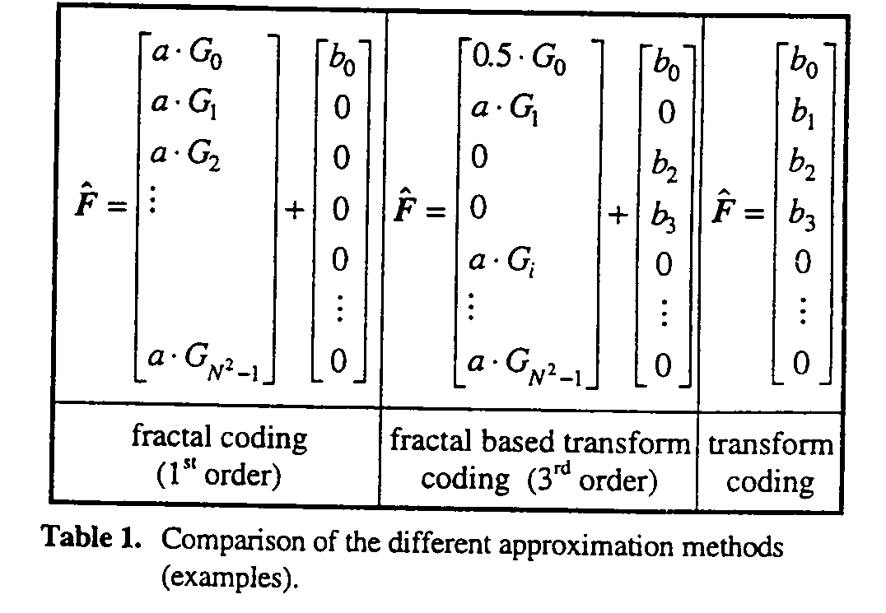
- Fast Codebook Search Scheme
The search for a fractal transform can be seen as a search in a codebook.

- Coder Description
The coding algorithm can be expressed:
- Initialization.
- Search the best new block code.
- Fulfills conditions then stop.

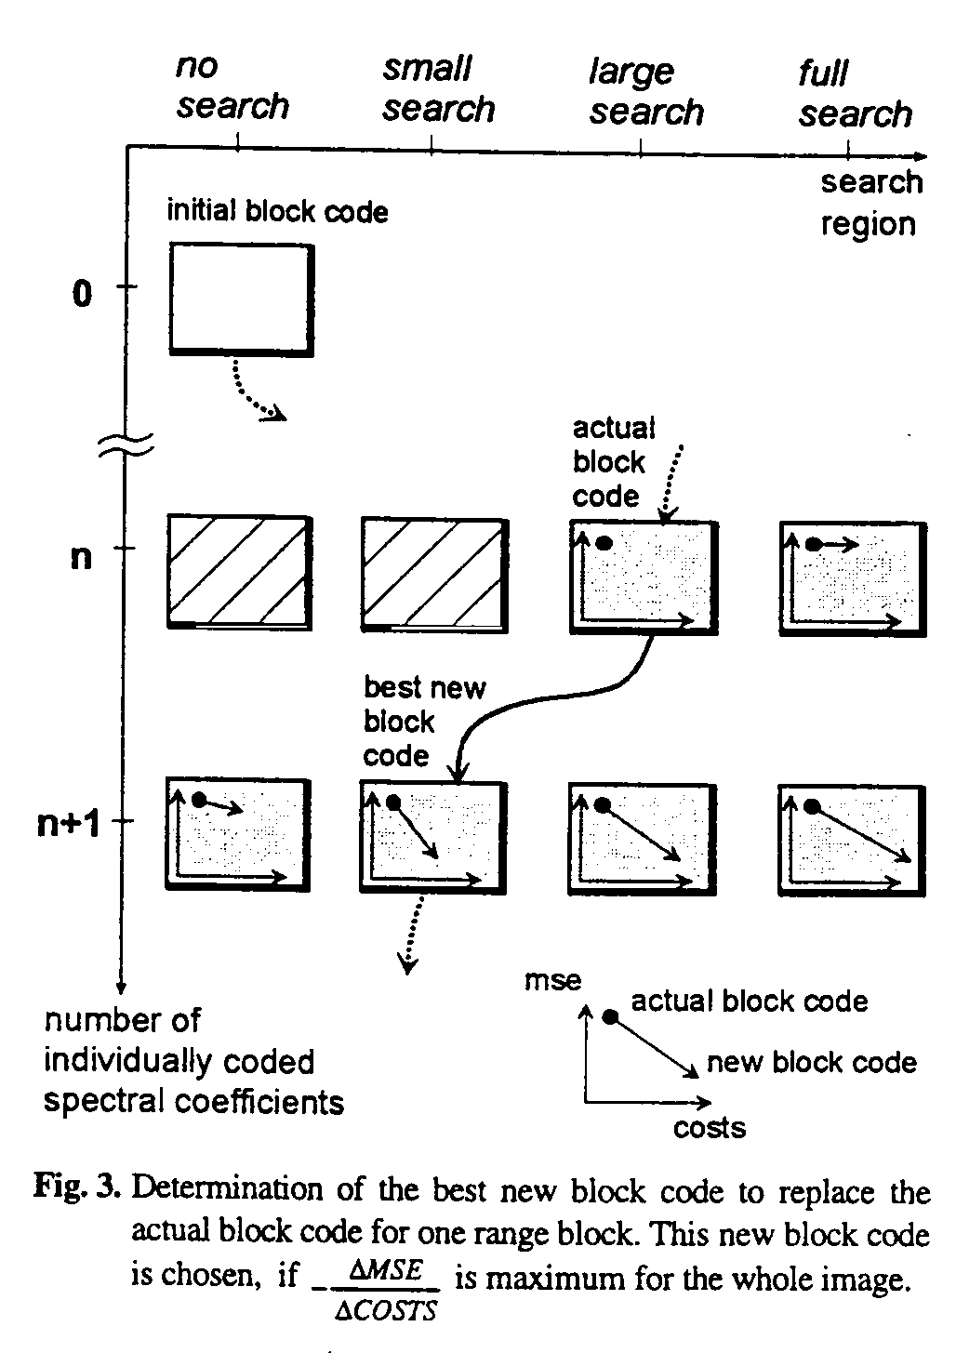

- Experimental Results

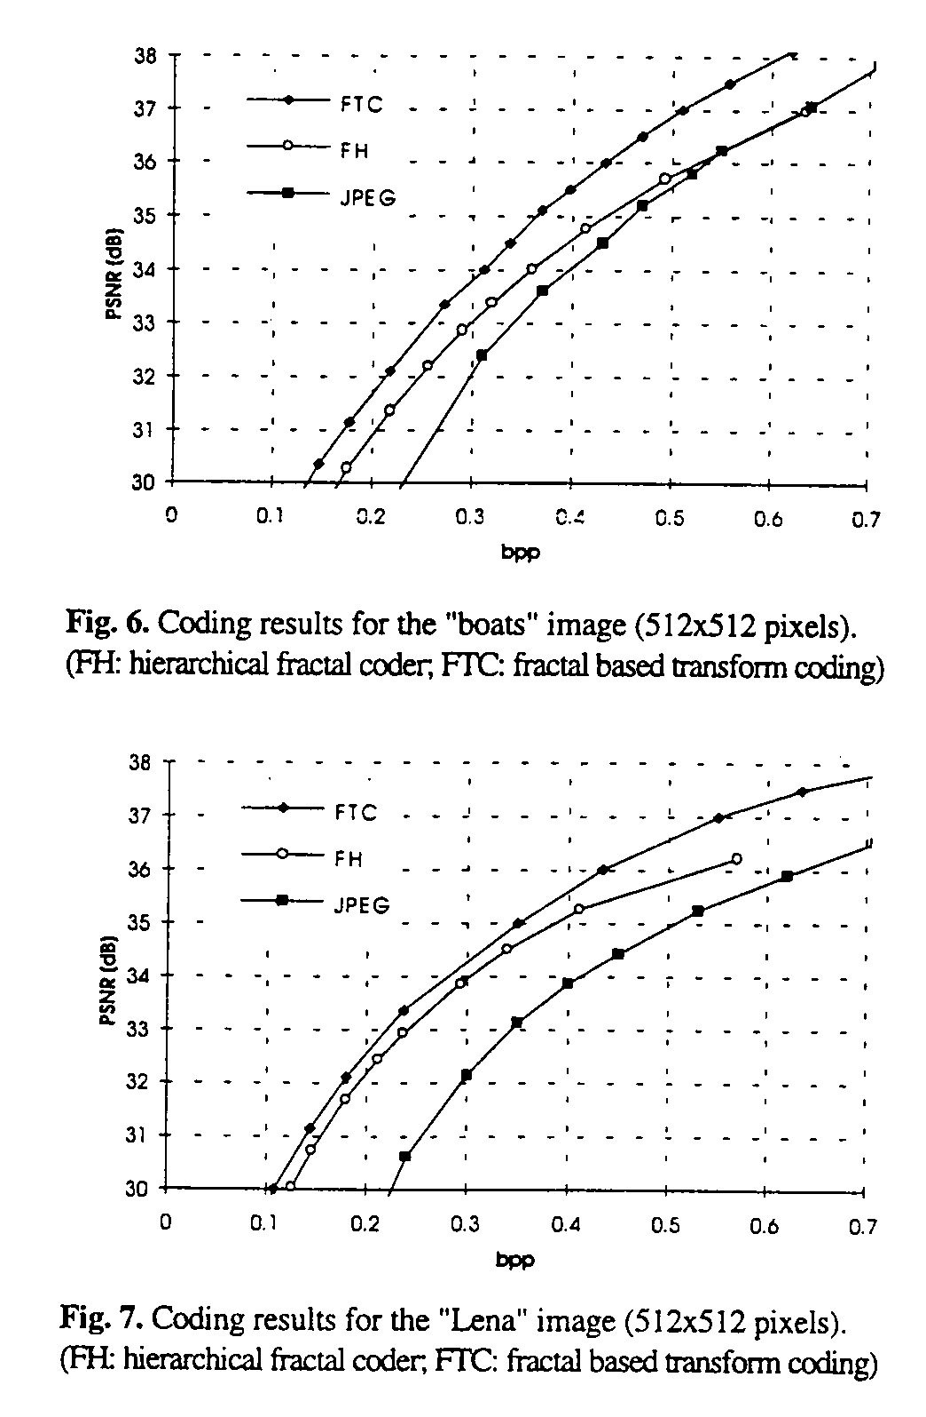

Created by : Chia-Hao Yang
Date : May 20, 1998

